1. A screenshot of a computer

   Description automatically generated
2. A screenshot of a login

   Description automatically generated
3. A white background with a blue and yellow flag

   Description automatically generated with medium confidence
4. A person holding a stick

   Description automatically generated with medium confidence
5. 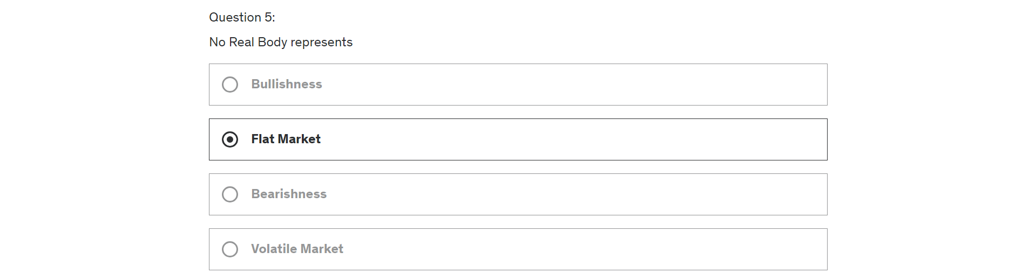
6. 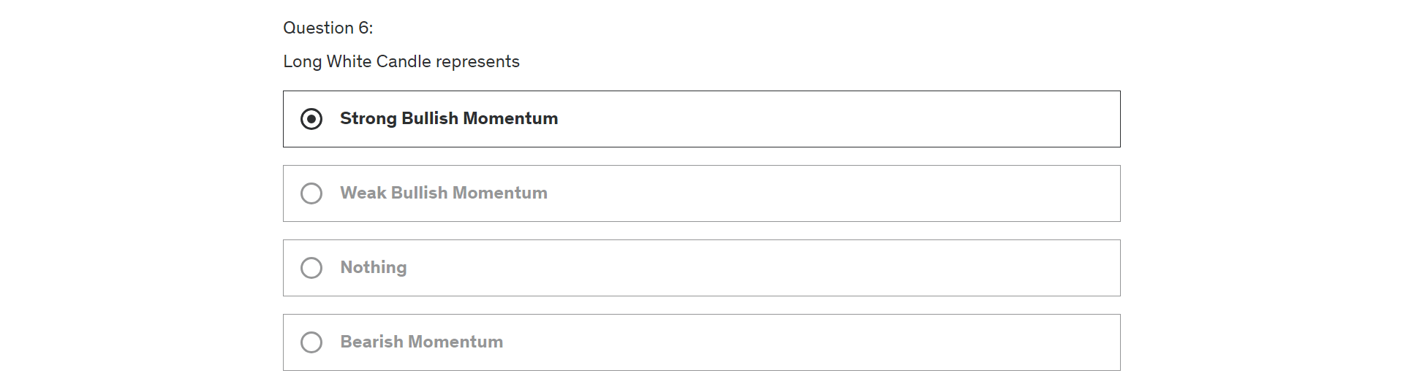
7. A screenshot of a computer

   Description automatically generated
8. A screenshot of a computer

   Description automatically generated
9. A close-up of a login screen

   Description automatically generated
10. A screenshot of a computer

    Description automatically generatedA screenshot of a computer

    Description automatically generated